Game Programming 101 – Unity Specifics

Intro to Unity UI
Unity (https://unity3d.com/) is one of our top choices for game development, allowing us to make PC, Xbox 360/One/X, PS3/4/Pro, Android, and IOS games with the same source code. We will be using C# as our programming language. C# is a commonly used language that is part of Microsoft .Net, one of the preeminent programming platforms for business application and game development. We will explore the Unity UI by examining a simple game called Apple Picker – using baskets to collect dropped apples:
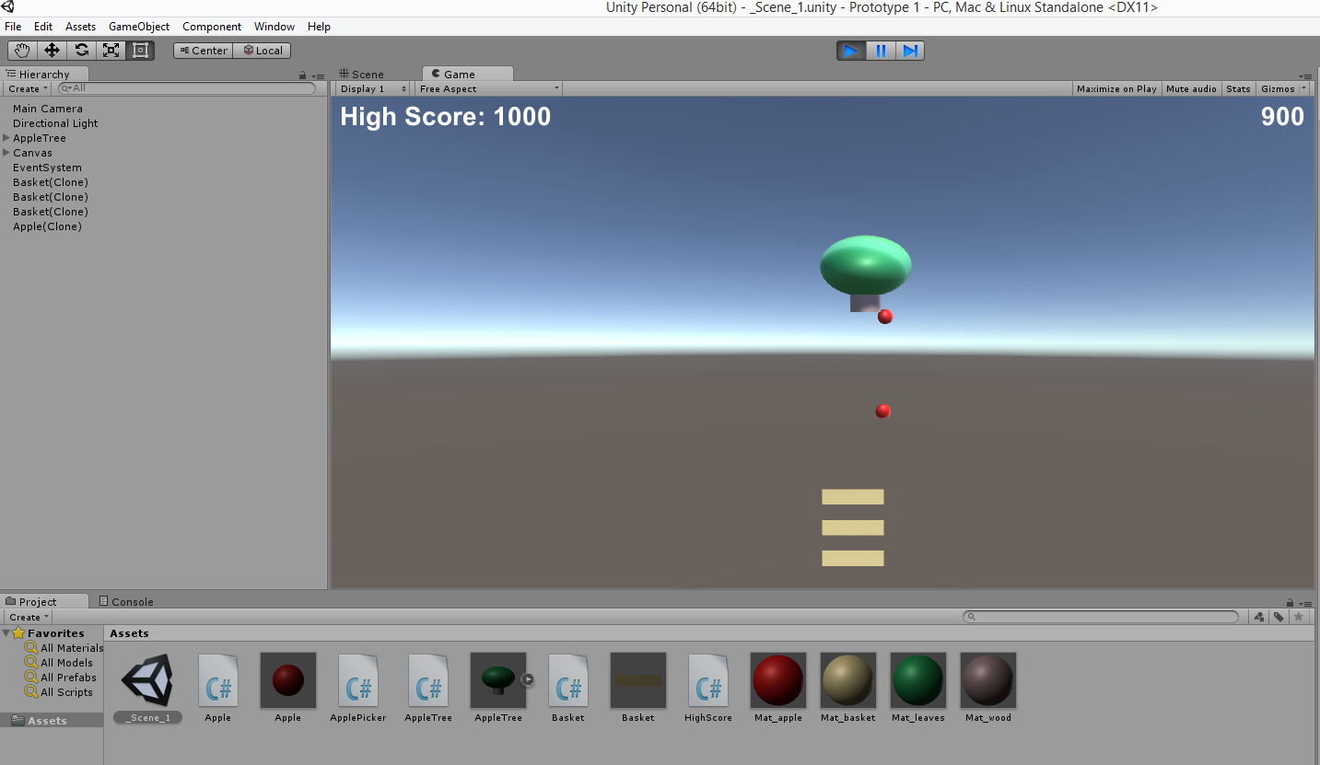
Castle Shot
We will work on replicating the core components of ‘Angry Birds’ in Unity, with a slingshot and castle:

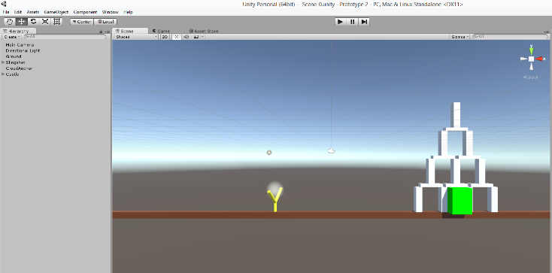
3D First Person
We will explore how 3D / first / third person perspective games are created in Unity:

Homework
Students will be expected to:
- Attend all 3 sessions if possible
- Have access to Unity outside of class (available for free here: https://store.unity.com/ for personal and educational use)
- Complete 3 homework assignments associated with class:
  - Apple Picker Mods (using if statements and loops) – 1 to 2 ½ hours
  - Castle Shot Mods (using physics and time arithmetic) – 2 to 3 ½ hours
  - Unity Assets Mods (using 3D modeling and Object Oriented Programming (OOP)) – 2 to 3 ½ hours

More about Unity
You can learn more about how Unity teaches STEM skills and Common Core concepts here: http://response.unity3d.com/unity-educator-toolkit-whitepaper?channel=web&eventname=ISTE-2016

